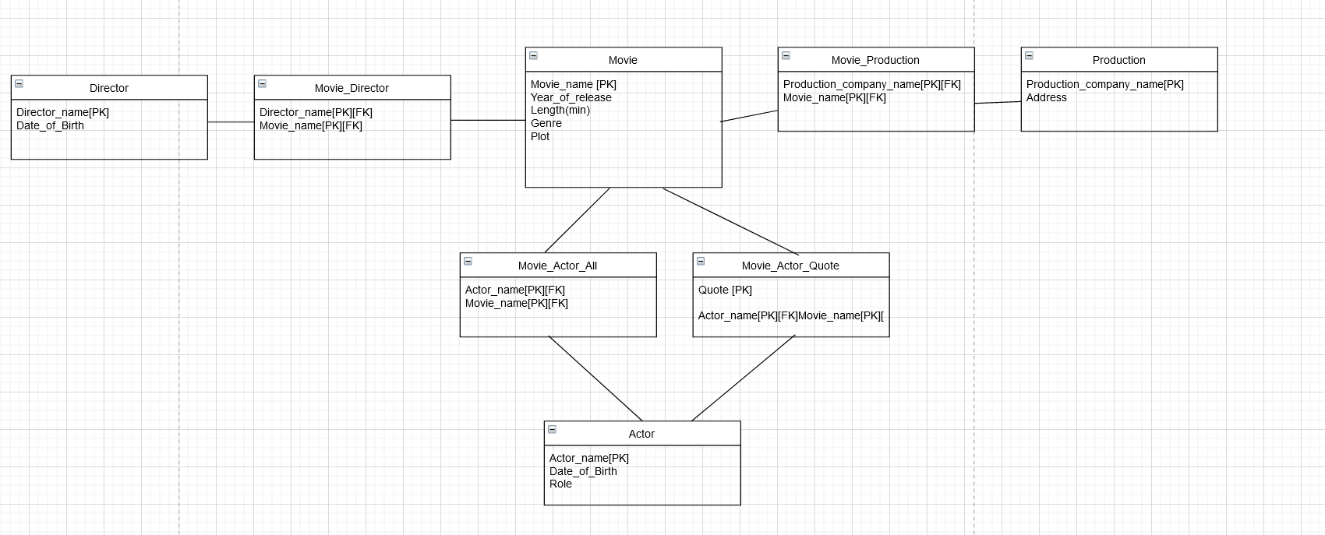

(Here the weak entities I found are one between movie and director, movie and production, movie and actor, and for movie and actor with quote)